Page |04

**Practical No: 02**

**Aim:** Write program to perform the following on signal

**A:** Create a triangle signal and plot a 3-period segment.

**Program Code:**

from scipy import signal

import matplotlib.pyplot as plot

import numpy as np

t = np.linspace(0, 1, 1000, endpoint=True)

plot.plot(t, signal.sawtooth(2 * np.pi * 5 * t))

plot.xlabel('Time')

plot.ylabel('Amplitude')

plot.title('Signal')

plot.axhline(y=0, color='k')

plot.show()

**Output:**

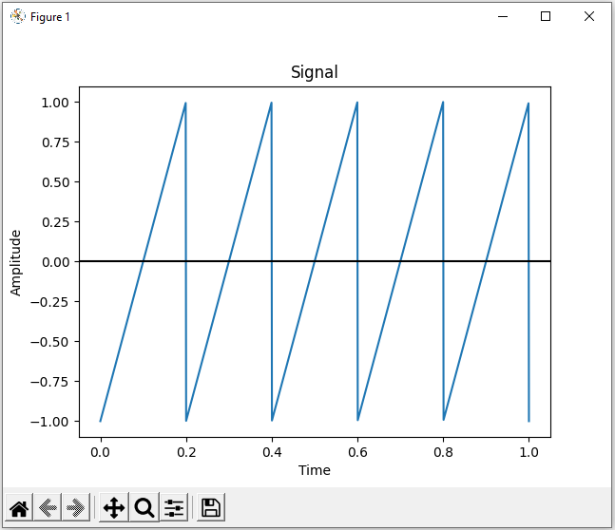

Page |05

**B:** For a given signal, plot the segment and compute the correlation between them.

Page 3

Correlation is a mathematical technique to see how close two things are related. In image processing terms, it is used to compute the response of a mask on an image.

**Program Code:**

import sklearn

import numpy as np

import matplotlib.pyplot as plt

import pandas as pd

y = pd.Series([1, 2, 3, 4, 3, 5, 4])

x = pd.Series([1, 2, 3, 4, 5, 6, 7])

correlation = y.corr(x)

plt.scatter(x, y)

plt.plot(np.unique(x), np.poly1d(np.polyfit(x, y, 1))(np.unique(x)), color='red')

plt.xlabel('x axis')

plt.ylabel('y axis')

plt.title('Correlation')

plt.show()

**Output:**

